LAB 1: IMPACT OF RTT ON NETWORK PERFORMANCE

This simulation shows how the RTT affects the performance of the network. The network in the figure below has an FTP server running on node n0 and the client is node n1. We run the simulation for 20 seconds by taking 5 different values of RTT. The packet size chosen is 1024 bytes. The link speed between n0 & n1 is 1 Mbps. This simulation is assuming that there are no packet drops in the link n0 – n1.

The RTT values the simulation uses are 2 ms , 50 ms, 100 ms, 250 ms and 500 ms. RTT value is twice the value of Link Delay.

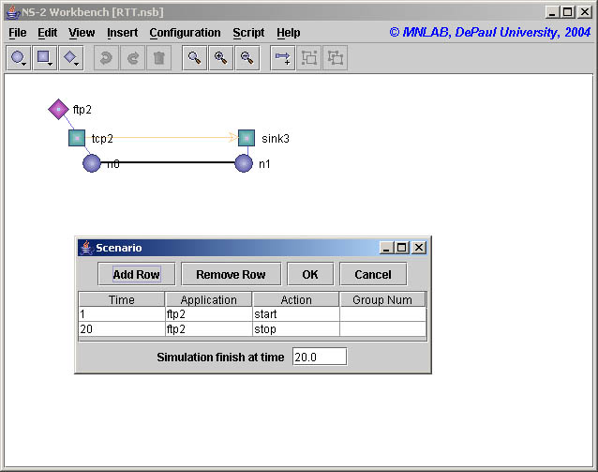

Results:-

By observing the graph during the 1st second & the 2nd second, we notice that the throughput increases very fast which is because of the slow start nature of TCP Tahoe.

Summary:-

RTT | Throughput | Efficiency
2 ms | 0.96 Mbps | 96.10%
50 ms | 0.95 Mbps | 95.40%
100 ms | 0.94 Mbps | 94.30%
250 ms | 0.58 Mbps | 58.50%
500 ms | 0.28 Mbps | 28.20%

The efficiency is calculated by normalizing the throughput based on the link speed.

Efficiency = Throughput / Link Speed

Conclusions:-

With the increase in the value of RTT, the throughput decreases and thereby the performance of the network decreases.

How to generate trace file:

$ ns RTT.tcl
n0: 0
n1: 1
Simulation completed.

Script used is
#!/bin/csh
set i = 0
while ($i < 21)
awk 'int($2)=='$i' && $1=="r" && $4==1 && $5=="tcp" {pkt = pkt + $6 - 40} END {print '$i'": " pkt}' RTT.tr
set i = `expr $i + 1`
end

