LAB 2: IMPACT OF PACKET LOSS ON NETWORK PERFORMANCE

This simulation shows the affect of packet size on the performance of the network. The network in the figure below has an FTP server running on node n0 and the client is node n1. We run the simulation for 20 seconds by taking 5 different percentages of packet loss. The link speed of the link between n0 & n1 is 1 Mbps with a delay of 10 ms.

The percentage of packet loss taken for this lab are 1%, 2%, 5%, 10% and 30%. The packet loss can be set by changing the Error Model to Error Model from None under the Link Properties. Then by clicking the Configure tab, the error Rate can be set.

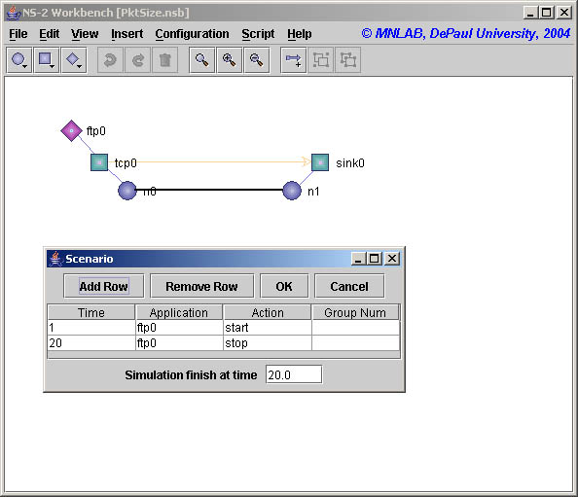

Results:-

By comparing the graphs of 1% packet loss and 2% packet loss during the first 3 seconds we see that because of the packet loss, the performance decrease significantly. And after the 3rd second, TCP tries to retransmit so the efficiency is high at the 4th second, but then again it decreases. So, this is the reason it graph fluctuates because of retransmission of lost packets.

Summary: -

Packet Loss | Throughput | Efficiency
1% | 0.53 | 53.51%
2% | 0.24 | 24.08%
5% | 0.07 | 7.36%
10% | 0 | 0.50%
30% | 0 | 0.16%

The efficiency is calculated by normalizing the throughput based on the link speed.

Efficiency = Throughput / Link Speed

Conclusions:-

Throughput is inversely proportional to packet loss. With the increase in the percentage of packet loss, the throughput decreases and thereby the performance decreases.

How to generate trace file:

$ ns PktLoss.tcl
n0: 0
n1: 1
Simulation completed.

Script used is
#!/bin/csh
set i = 0
while ($i < 21)
awk 'int($2)=='$i' && $1=="r" && $4==1 && $5=="tcp" {pkt = pkt + $6 - 40} END {print '$i'": " pkt}' PktLoss.tr
set i = `expr $i + 1`
end

