LAB 3: IMPACT OF PACKET SIZE ON NETWORK PERFORMANCE

This simulation shows how the packet size affects the performance of the network. The network in the figure below has an FTP server running on node n0 and the client is node n1. We run the simulation for 20 seconds by taking 5 different packet sizes. The link speed of the link between n0 & n1 is 1 Mbps with a delay of 10 ms.

The packet sizes we simulate are 32 bytes, 128 bytes, 256 bytes, 512 bytes and 1024 bytes. The packet size can be set by setting value of pcktsize under the Packet tab of TCP Tahoe Properties of tcp0.

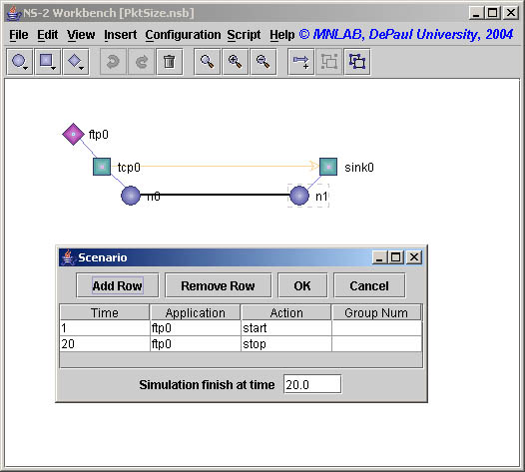

Results: -

By observing the graph during the 1st second & the 2nd second, we notice that the throughput increases very fast which is because of the slow start nature of TCP Tahoe.

Summary: -

Packet Size | Throughput | Efficiency
32 bytes | 0.24 Mbps | 24.40%
128 bytes | 0.75 Mbps | 75.87%
256 bytes | 0.86 Mbps | 86.17%
512 bytes | 0.92 Mbps | 92.48%
1024 bytes | 0.96 Mbps | 96.01%

The efficiency is calculated by normalizing the throughput based on the link speed.

Efficiency = Throughput / Link Speed

Conclusions:-

Throughput is directly proportional to the packet size. With the increase in packet size the throughput increases and thereby the performance of the network increases.

How to generate trace file:

$ ns PktSize.tcl
n0: 0
n1: 1
Simulation completed.

Script used is
#!/bin/csh
set i = 0
while ($i < 21)
awk 'int($2)=='$i' && $1=="r" && $4==1 && $5=="tcp" {pkt = pkt + $6 - 40} END {print '$i'": " pkt}' PktSize.tr
set i = `expr $i + 1`
end

