LAB 4: NETWORK PERFORMANCE OF INTERACTIVE & BULK TRAFFIC

This simulation shows difference between the average throughput of interactive traffic (web & telnet) and bulk traffic (FTP). The network in the figure below has a server node n0 running FTP, Telnet & a Web server. The client nodes are n2, n3 and n4. We run the simulation for 20 seconds. The link speed of the link between n0 & n1 is 1 Mbps with a delay of 10 ms. The packet size for tcp0 & tcp1 are 1000 bytes and the main page size for Web server is 5000 with 10 objects embedded in it each of size 10 kb. The two clients WClient1 & WClient2 has page request frequency of 1 sec each.

Setting the frequency of page request:

Double clicking WClient1 will pop up WebClient Properties. The page request frequency is Poisson Request Sequence.

The page size at the server can be set by double clicking the WServer0, which will pop up the WebServer Properties. Under the Page Pool Generator, we can select a single web page which is PagePool/Math or a composite web page which is PagePool/CompMath. By clicking on Configure we can set the page size.

Network Diagram:-

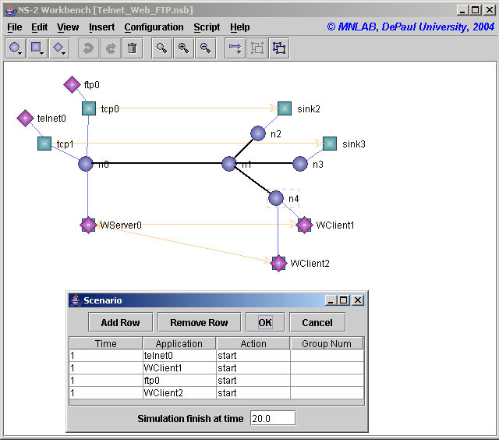
Results: -

By observing the graph we see that the efficiency for FTP is much higher than Web throughput and Telnet throughput, which shows the aggressive nature of FTP.

Summary: -

The efficiency is calculated by normalizing the throughput based on the link speed.

Efficiency = Throughput / Link Speed

The link utilization for the link between n1 & n2 is calculated by:
r1 = sum of all packets received by n1 every second
r2 = sum of all packets received by n2 every second

Link utilization = (r1 + r2) * 8 / Link Speed

Service | Throughput | Efficiency
Telnet | 0.01 | 1.09%
Web | 0.04 | 4.55%
FTP | 0.89 | 89.51%

Conclusions:-

FTP is very aggressive in nature while Telnet is the least.

How to generate trace file:

$ ns Telnet_Web_FTP.tcl
n0: 0
n1: 1
n4: 2
n2: 3
n3: 4
Simulation completed.

Script used for throughput is

#!/bin/csh
set i = 0
while ($i < 21)
awk 'int($2)=='$i' && $1=="r" && $4==3 && $5=="tcp" {pkt = pkt + $6 - 40} END {print '$i'": " pkt}' Telnet_Web_FTP.tr
set i = `expr $i + 1`
end

Script used for utilization is

#!/bin/csh
set i = 0
while ($i < 21)
awk 'int($2)=='$i' && $3 == 2 && $4 == 1 {pkt = pkt + $6 - 40} END {print '$i'": " pkt}' Telnet_Web_FTP.tr
set i = `expr $i + 1`
end

