Lab 5: IMPACT OF WINDOW SIZE ON NETWORK PERFORMANCE

This simulation shows how the sender’s window size affects the performance of the network. The network in the figure below has an FTP server running on node n0 and the client is node n1. We run the simulation for 20 seconds by taking 5 different packet sizes. The link speed of the link between n0 & n1 is 1 Mbps with a delay of 10 ms.

The window sizes we simulate are 1 Kb, 2 Kb, 3 Kb, 4 Kb and 10 Kb. The Window size can be set by setting value of win under the Window tab of TCP Tahoe Properties of tcp6 shown in figure.

Network Diagram: -

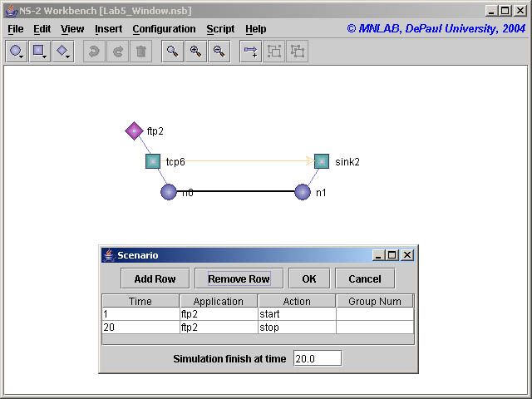

Results: -

By observing the graph during the 1st second & the 2nd second, we notice that the throughput increases very fast which is because of the slow start nature of TCP Tahoe.

Summary: -

Window Size | Throughput | Efficiency
1 Kb | 0.27 Mbps | 27.91
2 Kb | 0.55 Mbps | 55.78
3 Kb | 0.83 Mbps | 83.62
4 Kb | 0.95 Mbps | 95.91
10 Kb | 0.95 Mbps | 95.91

The efficiency is calculated by normalizing the throughput based on the link speed.

Efficiency = Throughput / Link Speed

Conclusions:-

Throughput is directly proportional to the window size to some extent. Here in this simulation, where the packet size was 1 Kb & link speed was 1 Mbps and there was no packet loss, the throughput was increasing with the increase in window size form 1 Kb to 4 Kb and then any further increase in the window size had no affect on the throughput as the throughput was maximum when the window size was 4 Kb. With the increase in window size the throughput increases and thereby the performance of the network increases but to some limited value of window size. In this example the threshold was 4 Kb and after that the throughput was constant.

How to generate trace file:

$ ns Window.tcl
n0: 0
n1: 1
Simulation completed.

Script used is
#!/bin/csh
set i = 0
while ($i < 21)
awk 'int($2)=='$i' && $1=="r" && $4==1 && $5=="tcp" {pkt = pkt + $6 - 40} END {print '$i'": " pkt}' Window.tr
set i = `expr $i + 1`
end

