LAB 6: IMPACT OF DIFFERENT TCP FLAVORS ON NETWORK PERFORMANCE

The simulation is run over a small network with 6 nodes

n0 = Server router
n2 = Audio Stream server
n3 = FTP server

n1 = Client side router
n4 = Client host requesting audio stream
n5 = Client host downloading using FTP stream

The link speed for all the links is 1 Mbps and the packet size for both CBR & FTP packets are 1000 bytes. The transfer rate for the audio stream (UDP) is 1 Mbps. The window size for TCP is 20 Kbytes.

With the above configuration, the simulation is run as follow:

The FTP is initiated at the 1st second and it runs till 20 seconds. The audio stream starts at 5th seconds and stops at 15th second while the FTP still running till 25th second.

The same scenario is run with 4 different flavors of TCP
- TCP Tahoe
- TCP Reno
- TCP Vegas
- TCP SACK

Network Diagrams:

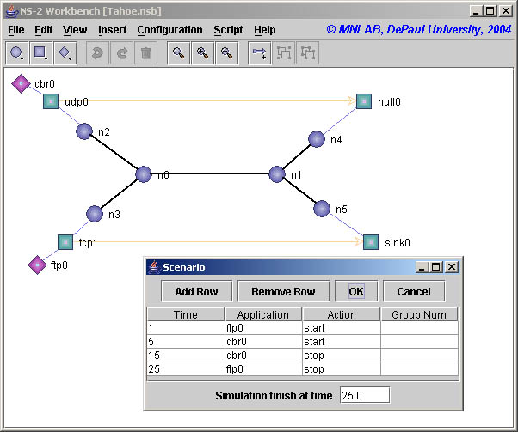
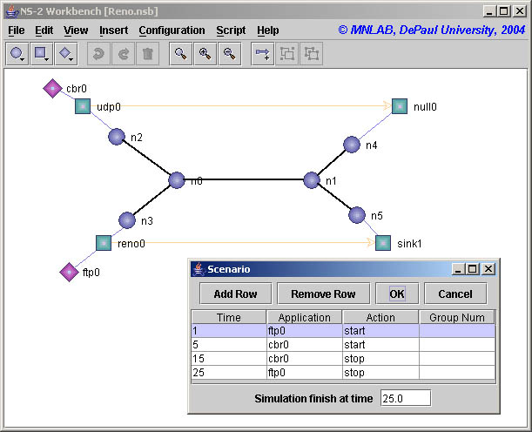
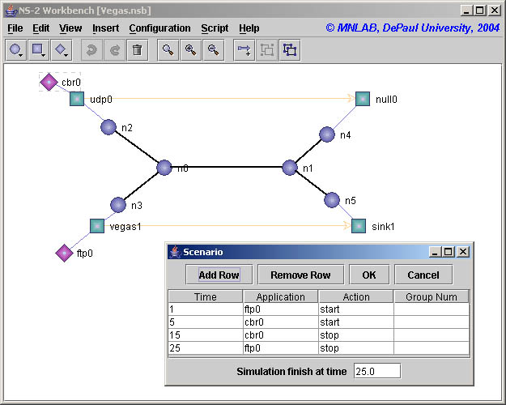

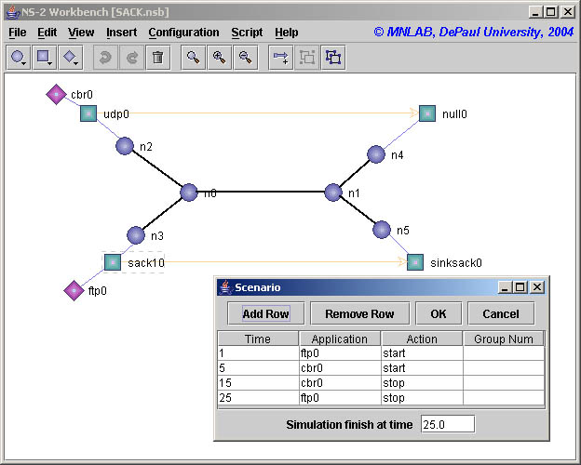

Results:-

Figure above show the Slow start behavior of TCP Tahoe. This simulation was run with an Error Model of 2% packet loss. We have already seen the slow start behavior of TCP in the lab before. But because of the packet loss, there is no throughput for FTP during the first 7 seconds. (Compare with Lab 2 : Efficiency with packet loss = 2%)

After 7 seconds, the efficiency should have increased to 50%, but it got to only 18% on the 8th second instead of 50% because of congestion in the link as a result of UDP traffic.

Time | Tahoe Efficiency | Reno Efficiency
1 | 0 | 0
2 | 0 | 0
3 | 0 | 0
4 | 0 | 0
5 | 0 | 0
6 | 0 | 0
7 | 15.2 | 15.2
8 | 16.8 | 16.8
9 | 12.8 | 12.8
10 | 5.6 | 4.8
11 | 3.2 | 0.8
12 | 0 | 4
13 | 2.4 | 4
14 | 4 | 4
15 | 29.6 | 23.2
16 | 56.8 | 66.4
17 | 57.6 | 63.2
18 | 62.4 | 67.2
19 | 50.4 | 48.8
20 | 36 | 24
21 | 45.6 | 29.6
22 | 44.8 | 58.4
23 | 17.6 | 0
24 | 8.8 | 0

The figure above shows the Fast Retransmission and Fast Recovery nature of TCP Reno. If we notice the efficiency for the 12th second of Reno & Tahoe, we see that the Reno recovers quickly from errors when compared with Tahoe.

Summary:-

The performance of TCP Vegas is the highest among all when the link is congested and the there is packet loss of 2%.

How to generate trace file:

$ ns TCP_Flavors.tcl
n0: 0
n1: 1
n2: 2
n3: 3
n4: 4
n5: 5
Simulation completed.

Script used is to get the UDP throughput is

#!/bin/csh
set i = 0
while ($i < 21)
awk 'int($2)=='$i' && $1=="r" && $4==4 && $5=="cbr" {pkt = pkt + $6 - 40} END {print '$i'": " pkt}' TCP_Flavors.tr
set i = `expr $i + 1`
end

Script used is to get the FTP throughput is

#!/bin/csh
set i = 0
while ($i < 21)
awk 'int($2)=='$i' && $1=="r" && $4==5 && $5=="tcp" {pkt = pkt + $6 - 40} END {print '$i'": " pkt}' TCP_Flavors.tr
set i = `expr $i + 1`
end

Script used is to get the UDP throughput is

#!/bin/csh
set i = 0
while ($i < 21)
awk 'int($2)=='$i' && $1=="r" && $4==4 && $5=="cbr" {pkt = pkt + $6 - 40} END {print '$i'": " pkt}' TCP_Flavors.tr
set i = `expr $i + 1`
end

