Question number 1:
Is there a significant difference between male and female in terms of confidence in four different disciplinary fields?

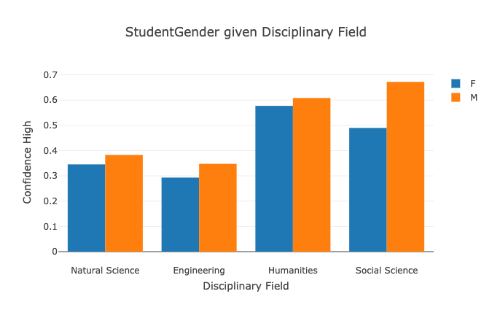
From this bar plot, male writers tend to use high confident words in their papers in all four disciplinary fields. This might suggest that male students are more confident about the arguments presented in their papers, which might further indicate that they tend to be more confident in the academic field and even in their daily life.
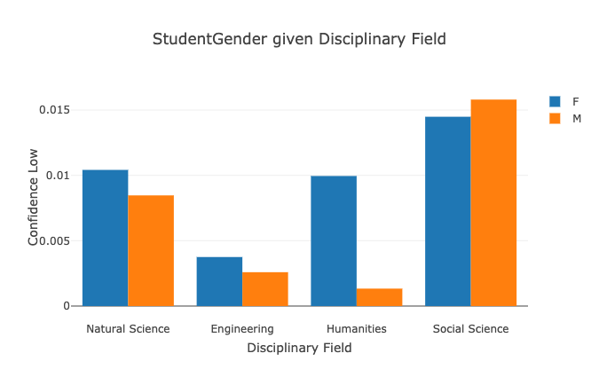
From this bar plot, it shows that female students use more low confident words in Natural Science, Engineering and Humanities than their male peers do. However, this trend does not hold for Social Science. This graph almost demonstrates a similar counter trend when compared to the first diagram. However, since one of the fields about violates it, this could help us to further specify our research question by analyzing this field.

Question 2:
Is the student status affect their use of expert vocabulary?
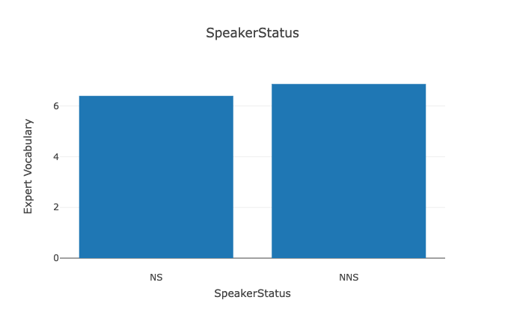
The result from the diagram above demonstrates that non-native speakers tend to use slightly more expert vocabulary in their papers than native speakers. However, since the gap in this graph is trivial, we can research different disciplines to discover more stories. 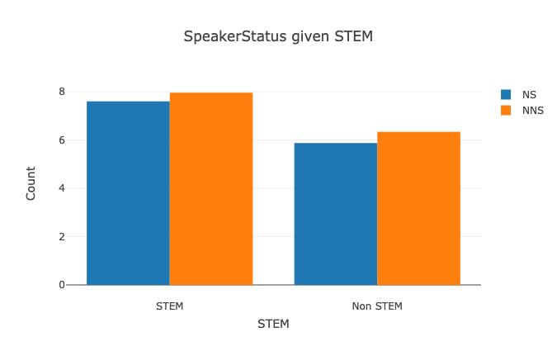
This graph groups all subjects into STEM and Non-STEM. The observation is that STEM fields use more expert vocabulary words. However, the difference between non-native speakers and native speakers is still insignificant, which might indicate that a good paper requires expert vocabulary for both non-native and native speakers.

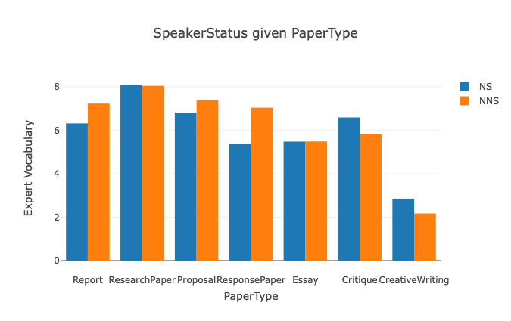
This graph provides a more interesting trend. It shows that in different types of paper, the number of expert vocabularies used by native and non-native speakers varies. The underlying reason might be the different requirements for different paper types. However, it also relates to speakers’ status. For example, since non-native speakers are generally unfamiliar with creative writing and critique in English, they use less expert vocabulary in those paper types.

